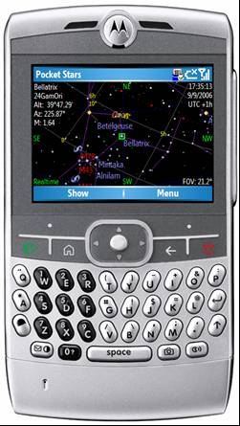
Pocket Stars SP Translation

1 Introduction 1
2 Scope of Work 1
3 Work Phases 1
4 Timeline 3
5 Some Background 3
6 Contact Acceptance and Survey Form 4
7 Translation Plan 5
8 Dialogs 15
9 Menus 21

Introduction
Pocket Stars SP is a star chart for Windows Mobile Smartphones. This document defines work to be performed for hire in translating Pocket Stars SP into languages other than English.

Scope of Work
You will translate 5 files used to localize Pocket Stars SP into a particular language, offer feedback, do a bit of testing, and get paid $300USD (plus $100 prorated by the percentage of star names translated) upon completion for your efforts.
All four Work Phases below must be completed to receive payment.
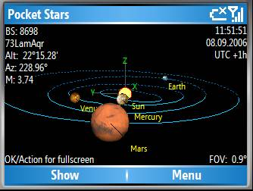
I would anticipate you would spend about two days on the translation effort, and about one day on the testing and feedback phase.

Work Phases
The work will be completed in four phases.

Contract Acceptance
If you accept this contract, please indicate this by returning the Contract Acceptance and Survey Form filled out. Upon completion of the work, a check will be issued to the name and address you provide on this form.

Translation
The following five files are to be translated.
In all of the file names below, the ZZZ value is a placeholder for a three letter code for each language as described below in the Language Codes section.
Later sections of this document contain the English language contents of these files with color coding added to denote the areas to be edited.
All files are provided in Word 2003 .doc format, but can be converted to other formats if you prefer.
Since the screen real estate of Smartphones is extremely precious, every effort should be made to not unduly increase the length of strings, menu items, and items in dialog boxes. Please consider using abbreviations if necessary.

PocketStars.ZZZ.rc.doc
This file contains text and layout information for all menus, dialogs, and strings used throughout the program. Source for this file is contained later in this document, as are the images of the menus and dialog resources it contains.

PocketStars.H.ZZZ.htm
This file contains the text of the help file. It is formatted as HTML so you can use simple formatting such as bold, bulleted lists, etc.

PocketStars.C.ZZZ.doc
This file contains text information about each of the 88 constellations. Of all the work items, this is the most flexible – the original English version of this file is taken from Wikipedia, and I have no problem with you trimming back the text to a single pithy sentence for each constellation.

PocketStars.S.ZZZ.txt
This text file contains localized star names.

PocketStars.W.ZZZ.doc
This word file contains text describing the features of Pocket Stars SP and will eventually be used to localize web pages advertising sale of the program.

Testing
After you return the five translated files, I will create a satellite DLL (a chunk of program which is separate from PocketStars, but will be loaded dynamically to extract the language resouces) for your language. The satellite DLL will be named PocketStars.ZZZ.dll, where the ZZZ value will be a three letter code for each language as described below in the Language Codes section.
If possible, I will loan you a Smartphone for a day or so with your satellite DLL loaded and you will exercise the program and note any problems encountered. This testing is ad hoc by nature – I’m not expecting you to fully check all boundary conditions, but will verify proper display of all dialogs and the help file.
Within Pocket Stars SP, you will be able to dynamically change languages by selecting Menu.Preferences.Language.
Typically, Smartphones are only provisioned with one or two languages, such as English/Spanish or Dutch/German. This means that the operating system itself only knows how to show its own User Interface using the provisioned languages.
But Pocket Stars SP lets you select a language which is not provisioned on the device, and the results in a couple of cases can be unexpected. For example, the date/time on the star chart and days of the week in Lunar Phase dialog will not be localized correctly unless the device is provisioned for the language selected in Pocket Stars.

Final Corrections, Acceptance, and Payment
Based on your testing feedback, a final round of changes will be made if necessary and upon acceptance you will be paid $300 USD. Payment will be made by check to the name and address provided on the acceptance form.

Timeline
If you decide to accept this contract, please indication your likely completion date along with your acceptance sheet.
Pocket Stars SP will automatically download the localized satellite DLL for the user selected language from my web site (www.nomadelectronics.com) automatically, so changes and updates can be made quickly, and new language translations can be added as they become available.

Some Background
After leaving Microsoft in 2000, I decided I wanted to sail around the world, and wanted to use celestial navigation enroute. To perform the somewhat tedious calculations I developed a program for the Pocket PC, and almost as an afterthought added a star chart. This eventually turned into a product and I released Pocket Stars PDA in late 2001. I’ve belatedly realized that just about nobody cares about celestial navigation, but many people enjoy having a nice star chat close at hand, and have added features steadily over the last few years. Never managed to sail around the world, though.
Also, I’m not an astronomer, physicist, or mathematician. Just a programmer.
Pocket Stars SP is the 3rd product I’ve marketed using the same basic codebase. Pocket Stars PDA is for Pocket PCs, while Pocket Stars PC is for desktop Windows. .
The PDA version is currently by far the largest seller with over 200,000 downloads to date (sales are about 1/10th of the downloads), but with the new generation of Smartphones such as the Motorola Q, the SP version should become more popular over the next year or two.
Pocket Stars SP has undergone a major overhaul during the last few months, and one of the new features is the ability to localize the product for any language. Only the Smartphone version is being localized at this time.
Any questions, contact jaybo@nomadelectronics.com.

Contact Acceptance and Survey Form
Please return this section to jaybo@nomadelectronics.com if you commit to the translation work
Yes, I will translate Pocket Stars SP into __________________ language. I anticipate completing the work in _______ days.
Signed: __________________________
Date: __________________________

Name:
Address:

Phone:
Email:

Survey
Since I don’t have resources to do a complete translation of all aspects of Pocket Stars some features are not being translated at this time. Could you please give your opinion on how important each of the following features would be to customers using your language?
Rating system:
1. Not important at all
2. Slightly important (< 10% of customers care)
3. Somewhat important (40% of customers care)
4. Really should be fixed (>60% of customers care)
5. Very important issue, customers won’t buy or use the product if not fixed.

Countries and Cities
Currently, countries and cities in the LatLong dialog are not localized. Since there are about 2000 cities in the database, this would be a huge effort.
Rating: ____________

Product Name
I’m assuming that the program name “Pocket Stars” will not be localized, but will be a brand like “CocaCola”. Any objections?
Rating: ____________

Translation Plan
The following is a suggested game plan for working on the translation. It generally progresses from the easier tasks to the more complicated.
Files shown in this section are provided here for reference only and you should only edit the electronic versions provided and not this document itself. The documents are provided in Word .doc format, but if you prefer I could convert the source documents to other formats.

Learn about Pocket Stars on the web
Browse to http://www.nomadelectronics.com/Smartphone/index.htm
to get an idea of the current version of Pocket Stars SP. The new version you will be translating has a number of additional features, but much remains the same.

Try running Pocket Stars
If you have a Pocket PC or Windows PC, you can run an existing version to get a feel for the program. If you already own a Smartphone, let me know and I’ll get you a beta of the current SP version.
Latest PC Version:
http://www.nomadelectronics.com/anonymous/PocketStars.msi
Latest PDA Version: http://www.nomadelectronics.com/anonymous/PocketStars.ppc30_arm.exe
To get more familiar with a typical QWERTY smartphone that will run this Pocket Stars SP, see:
http://direct.motorola.com/hellomoto/q/q-experience/q.html
For a non-QWERTY devices see:
http://www.pdadb.net/index.php?m=pdalist&list=smartphone

Language Codes
This table gives the LocaleID (LCID), displayed language name, and 3 letter code. The files you translate will contain the three letter code at the end of the filename.

0x0409, _T("English"), _T("ENU"), // English
0x000a, _T("Español - Spanish"), _T("ESP"), // Spanish
0x0007, _T("Deutsch - German"), _T("DEU"), // Germain
0x000c, _T("Français - French"), _T("FRA"), // French
0x0010, _T("Italiano - Italian"), _T("ITA"), // Italian
0x0004, _T("中文(简体) - Chinese"), _T("CHS"), // Chinese
0x0039, _T("हिंदी - Hindi"), _T("HIN"), // Hindi
// 0x0001, _T("العربية"), _T("ARA"), // Arabic
0x0016, _T("Português - Portuguese"), _T("PTB"), // Portuguese
//0x0445, _T("বাঢলা (ভারত) - Bengali"), _T("BNG"), // Bengali
0x0019, _T("русский - Russian"), _T("RUS"), // Russian
0x0011, _T("日本語 - Japanese"), _T("JPN"), // Japanese
0x0046, _T("ਪੰਜਾਬੀ - Punjabi"), _T("PAN"), // Punjabi
0x0012, _T("한국어 - Korean"), _T("KOR"), // Korean

Keyboard Shortcuts
Keyboard shortcuts come up often in the materials to be translated. The keyboard shortcuts in use depend on the type of keyboard available on the device. All devices use a 4 way rocker pad to rotate the horizon or azimuth (left and right rocker keys) and change the altitude (up and down rocker keys).

Devices Without QWERTY keyboards
Smartphones without QWERTY keyboards use the following phone buttons to control zooming and there is no way to modify these settings:
1 = 180° Field of view (FOV)
2 = 120°
3 = 90°
4 = 60°
5 = 45°
6 = 36°
7 = 30°
8 = Zoom In
0 = Zoom Out

* Show Info. Show and hide information on the selected object.
# Show Time. Show and hide the date and time.

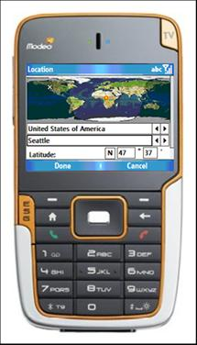

Devices with QWERTY keyboards
Smartphones with full QWERTY keyboards can use keyboard accelerators for some functions. If you decide that the English accelerators are inappropriate, write down the substitutes here. You will need to change these values in a number of places such as the help file and strings within the resource file.
Note that in some cases the choice of an accelerator was based on physical location on the keyboard rather than mnemonic value. So, for example, all of the keys controlling star magnitudes are directly adjacent to one another. Also note that a given key can have only one function, so you’ll need to make choices like whether “M” is “by Month” or “by Minute”.
Please give me a heads up before embarking on changing the key assignments.

Group | Function | English Key | Your language Key
Zoom | In | I
 | Out | O
Star Magnitudes | Auto | A
 | Show more stars | S
 | Show fewer stars | Q
Color Scheme | Cycle through color schemes | C
Zenith | Position Zenith point at center of star chart | Z
Time Animation | Next (step time forward) | N
 | Back (step time backward) | B
 | Realtime | R
 | By Minute | E
 | By Hour | H
 | By Day | D
 | By Week | W
 | By Month | M
2D or 3D | Switch between 2D and 3D views | . (that’s a period)
Body info at top left | Show or hide | T
Time at top right | Show or hide | Y

Translate PocketStars.W.ZZZ.doc
This file contains a description of Pocket Stars features for marketing purposes. This file will be ultimately used on the web, but for now please edit in Microsoft Word format, maintaining existing formatting, and later I’ll convert this to HTML.

Translate PocketStars.H.ZZZ.htm
This is the help file. It’s short and will help get you oriented. This file is provided as HTML, and you can edit it in Word or any other HTML editor and use formatting such as bold and bulleted lists. Note that if you changed the key accelerators above, you’ll need to modify the key assignment references in this file.

Translate PocketStars.ZZZ.rc.doc
This is the resource file containing dialogs, menus, and strings used by the program. This is really the key to the whole thing, and will appear a bit daunting at first. But only a small portion of the file requires your attention.
First off, you’re only modifying strings in this file, which means stuff between “quotation marks”. Only the portions of this file which are highlighted below require translation. If a string contains a list of items separated by commas or semicolons, you must keep the translated words in the exact same order as the original version.
Strings like “UTC” are supposedly not to be translated (see: http://en.wikipedia.org/wiki/Coordinated_Universal_Time), but I would welcome your feedback on this.
Do not translate (but do preserve) formatting information within the strings, such as:
\r | carriage return
\n | linefeed
%2.1lf | formatting strings
&& | Escape &

Note that if you’re editing the source files in Word, you can turn on Tools.TrackChanges and View.Markup to easily compare the translated and original versions. If you return the files to me with TrackChanges enabled, and never “Accept/Reject” changes, we can keep a log of how the translation progresses over time.

PocketStars.rc

/////////////////////////////////////////////////////////////////////////////
//
// Menu
//

IDR_MenuBarMain MENU
BEGIN
MENUITEM "Show", IDM_VIEW
POPUP "Menu"
BEGIN
MENUITEM "Location", IDM_LOCATION
MENUITEM "Time", IDM_TIME
POPUP "View"
BEGIN
MENUITEM "2D - Star Chart", ID_DISPLAY_2D
MENUITEM "3D - Orrery", ID_DISPLAY_3D
MENUITEM "Lunar Phase", IDM_LUNARPHASE
MENUITEM "Rise && Set", IDM_RISESET

END

POPUP "Animation"
BEGIN
MENUITEM "By Minute\tE", ID_ANIMATION_BYMINUTE
MENUITEM "By Hour\tH", ID_ANIMATION_BYHOUR
MENUITEM "By Day\tD", ID_ANIMATION_BYDAY
MENUITEM "By Week\tW", ID_ANIMATION_BYWEEK
MENUITEM "By Month\tM", ID_ANIMATION_BYMONTH
MENUITEM SEPARATOR
MENUITEM "Step + \tN", ID_ANIMATION_STEP_PLUS
MENUITEM "Step - \tB", ID_ANIMATION_STEP_MINUS
MENUITEM "RealTime\tR", ID_ANIMATION_REALTIME

END

POPUP "Star magnitudes"
BEGIN
MENUITEM "Auto\tA", IDM_MAG_AUTO
MENUITEM "Mag 2", IDM_MAG_2
MENUITEM "Mag 2.5", IDM_MAG_25
MENUITEM "Mag 3", IDM_MAG_3
MENUITEM "Mag 4", IDM_MAG_4
MENUITEM "Mag 5", IDM_MAG_5
MENUITEM "Mag 6", IDM_MAG_6
MENUITEM "Mag 7", IDM_MAG_7

END

POPUP "Horizon - Rotate"
BEGIN
MENUITEM "North West", IDM_HORIZON_1
MENUITEM "North", IDM_HORIZON_2
MENUITEM "North East", IDM_HORIZON_3
MENUITEM "West", IDM_HORIZON_4
MENUITEM "Home - Zenith\tZ", IDM_HORIZON_5
MENUITEM "East", IDM_HORIZON_6
MENUITEM "South West", IDM_HORIZON_7
MENUITEM "South", IDM_HORIZON_8
MENUITEM "South East", IDM_HORIZON_9
MENUITEM "Flip East - West", IDM_HORIZON_0

END
MENUITEM "Find - Info", IDM_FIND
POPUP "Preferences"
BEGIN
MENUITEM "Star Chart", IDM_PREFERENCES
MENUITEM "Language", IDM_LANGUAGE

END

POPUP "Help"
BEGIN
MENUITEM "Help", IDM_HELP
MENUITEM "About", IDM_ABOUT
MENUITEM "Registration", IDM_REGISTRATION
MENUITEM "Exit", IDM_EXIT

END

END

END

IDR_MenuBarDoneCancel MENU
BEGIN
MENUITEM "Done", IDM_ITEM_DONE
MENUITEM "Cancel", IDM_ITEM_CANCEL

END

IDR_MenuBarFind MENU
BEGIN
MENUITEM "Done", IDOK
POPUP "Menu"
BEGIN
MENUITEM "Image", IDM_ITEM_IMAGE
MENUITEM "Info", IDM_ITEM_INFO
MENUITEM "Web", IDM_ITEM_WEB
MENUITEM "Cancel", IDCANCEL

END

END

IDR_MenuBarDone MENU
BEGIN
MENUITEM "Done", IDOK

END

IDR_MenuBarDoneRegister MENU
BEGIN
MENUITEM "Done", 0
MENUITEM "Register", 0

END

/////////////////////////////////////////////////////////////////////////////
//
// Dialog
//

IDD_LOCATION DIALOG 0, 0, 154, 196

STYLE DS_SETFONT | DS_MODALFRAME | WS_POPUP | WS_CAPTION | WS_VSCROLL | WS_SYSMENU
CAPTION "Location"
FONT 10, "Nina"
BEGIN
LISTBOX IDC_COUNTRY_LIST,1,41,81,10,LBS_NOINTEGRALHEIGHT | WS_TABSTOP
CONTROL "Country",IDC_COUNTRY_SPIN,"msctls_updown32",UDS_WRAP | UDS_SETBUDDYINT | UDS_ALIGNRIGHT | UDS_AUTOBUDDY | UDS_ARROWKEYS | UDS_HORZ | 0x200,85,42,20,10
LISTBOX IDC_CITY_LIST,1,51,81,10,LBS_NOINTEGRALHEIGHT | WS_TABSTOP
CONTROL "City",IDC_CITY_SPIN,"msctls_updown32",UDS_WRAP | UDS_SETBUDDYINT | UDS_ALIGNRIGHT | UDS_AUTOBUDDY | UDS_ARROWKEYS | UDS_HORZ | 0x200,85,52,20,11
PUSHBUTTON "N",IDC_LOCATION_LAT_NS,43,62,11,10
EDITTEXT IDC_LAT_DEG,55,61,20,11,ES_AUTOHSCROLL | ES_WANTRETURN | ES_NUMBER
EDITTEXT IDC_LAT_MIN,82,61,16,11,ES_AUTOHSCROLL | ES_WANTRETURN | ES_NUMBER
PUSHBUTTON "E",IDC_LOCATION_LONG_EW,43,74,11,10
EDITTEXT IDC_LONG_DEG,55,73,20,11,ES_AUTOHSCROLL | ES_WANTRETURN | ES_NUMBER
EDITTEXT IDC_LONG_MIN,82,73,16,11,ES_AUTOHSCROLL | ES_WANTRETURN | ES_NUMBER
CTEXT "Static",IDC_MAP_PLACEHOLDER,0,0,107,41,WS_BORDER
LTEXT "Latitude:",IDC_LOCATIONLatitude,3,64,40,10
LTEXT "Longitude:",IDC_LOCATIONLongitude,3,74,41,10
LTEXT "°",IDC_LAT_DEG_SYMBOL,76,61,10,10
LTEXT "°",IDC_LONG_DEG_SYMBOL,76,73,10,10
LTEXT "'",IDC_LONG_MIN_SYMBOL,100,73,10,10
LTEXT "'",IDC_LAT_MIN_SYMBOL,100,62,10,10

END

IDD_FIND DIALOG 0, 0, 155, 172

STYLE DS_SETFONT | DS_MODALFRAME | WS_POPUP | WS_CAPTION | WS_SYSMENU
CAPTION "Find - Info"
FONT 10, "Nina"
BEGIN
LISTBOX IDC_FIND_LBObjectType,1,0,102,10,LBS_NOINTEGRALHEIGHT | WS_TABSTOP
CONTROL "ObjectType",IDC_FIND_LBObjectTypeSpin,"msctls_updown32",UDS_WRAP | UDS_SETBUDDYINT | UDS_ALIGNRIGHT | UDS_AUTOBUDDY | UDS_ARROWKEYS | UDS_HORZ | 0x200,118,2,20,10
LISTBOX IDC_FIND_LBObject,1,10,102,10,LBS_SORT | LBS_NOINTEGRALHEIGHT | WS_TABSTOP
CONTROL "Object",IDC_FIND_LBObjectSpin,"msctls_updown32",UDS_WRAP | UDS_SETBUDDYINT | UDS_ALIGNRIGHT | UDS_AUTOBUDDY | UDS_ARROWKEYS | UDS_HORZ | 0x200,117,13,20,10
EDITTEXT IDC_FIND_RESULTS,0,21,104,30,ES_MULTILINE | ES_AUTOVSCROLL | WS_VSCROLL
PUSHBUTTON "Click to download Messier and Caldwell images.",IDC_FIND_MessierDownload,0,30,103,18,BS_MULTILINE
PUSHBUTTON "Click to download Constellation images.",IDC_FIND_ConstellationDownload,0,29,103,19,BS_MULTILINE
PUSHBUTTON "+",IDC_FIND_DSS_ZoomIn,120,36,14,9
PUSHBUTTON "-",IDC_FIND_DSS_ZoomOut,120,46,14,9
CONTROL "SDSS",IDC_FIND_DSS_Enable,"Button",BS_AUTOCHECKBOX | BS_NOTIFY | WS_TABSTOP,115,57,29,8

END

IDD_TIME DIALOG 0, 0, 154, 192

STYLE DS_SETFONT | DS_MODALFRAME | WS_POPUP | WS_CAPTION | WS_VSCROLL | WS_SYSMENU
CAPTION "Time"
FONT 10, "Nina"
BEGIN
CONTROL "Realtime",IDC_TIME_REALTIME,"Button",BS_AUTOCHECKBOX | BS_NOTIFY | WS_TABSTOP,1,1,80,11
CONTROL "DateTimePicker1",IDC_DATEPICKER,"SysDateTimePick32",WS_TABSTOP,12,12,99,11
CONTROL "DateTimePicker1",IDC_TIMEPICKER,"SysDateTimePick32",DTS_RIGHTALIGN | DTS_APPCANPARSE | WS_TABSTOP | 0x8,12,23,100,11
CONTROL "as UTC (GMT)",IDC_TIME_UTC,"Button",BS_AUTOCHECKBOX | BS_NOTIFY | WS_TABSTOP,12,34,99,11
LISTBOX IDC_TIME_ZONE_METHOD,12,54,91,11,LBS_NOINTEGRALHEIGHT | WS_TABSTOP
CONTROL "ObjectType",IDC_TIME_ZONE_METHODSpin,"msctls_updown32",UDS_WRAP | UDS_SETBUDDYINT | UDS_ALIGNRIGHT | UDS_AUTOBUDDY | UDS_ARROWKEYS | UDS_HORZ | 0x200,110,56,20,10
LISTBOX IDC_TIME_UTCOFFSET_LIST,12,66,91,11,LBS_NOINTEGRALHEIGHT | WS_TABSTOP
CONTROL "ObjectType",IDC_UTCOFFSET_LISTSpin,"msctls_updown32",UDS_WRAP | UDS_SETBUDDYINT | UDS_ALIGNRIGHT | UDS_AUTOBUDDY | UDS_ARROWKEYS | UDS_HORZ | 0x200,109,68,20,10
CONTROL "DST (Daylight Savings)",IDC_TIME_DST,"Button",BS_AUTOCHECKBOX | BS_NOTIFY | WS_TABSTOP,12,78,106,11
LTEXT "Time Zone:",IDC_TIME_STATICTIMEZONE,1,45,83,10

END

IDD_LUNAR DIALOG 0, 0, 154, 184

STYLE DS_SETFONT | DS_MODALFRAME | WS_POPUP | WS_CAPTION | WS_SYSMENU
CAPTION "Lunar Phase"
FONT 10, "Nina"
BEGIN
CONTROL "DateTimePicker1",IDC_DATEPICKER,"SysDateTimePick32",WS_TABSTOP,1,1,67,11
PUSHBUTTON "<<",IDC_LUNAR_MINUS,76,1,14,10
PUSHBUTTON ">>",IDC_LUNAR_PLUS,93,1,14,10

END

IDD_SPLASH DIALOG 0, 0, 154, 166

STYLE DS_SETFONT | DS_MODALFRAME | WS_POPUP | WS_CAPTION | WS_SYSMENU
CAPTION "Pocket Stars"
FONT 10, "Nina"
BEGIN
LTEXT "Splash",IDC_SPLASH_PLACEHOLDER,0,0,135,97,WS_BORDER

END

IDD_RISESET DIALOG 0, 0, 154, 200

STYLE DS_SETFONT | DS_MODALFRAME | WS_POPUP | WS_VISIBLE | WS_CAPTION
CAPTION "Rise Set"
FONT 10, "Nina"
BEGIN
LISTBOX IDC_FIND_LBObject,1,2,102,11,LBS_SORT | LBS_NOINTEGRALHEIGHT | WS_TABSTOP
CONTROL "Object",IDC_FIND_LBObjectSpin,"msctls_updown32",UDS_WRAP | UDS_SETBUDDYINT | UDS_ALIGNRIGHT | UDS_AUTOBUDDY | UDS_ARROWKEYS | UDS_HORZ | 0x200,117,3,20,10
CONTROL "DateTimePicker1",IDC_DATEPICKER,"SysDateTimePick32",WS_TABSTOP,1,16,72,11
PUSHBUTTON "<<",IDC_RISESET_MINUS,85,16,14,10
PUSHBUTTON ">>",IDC_RISESET_PLUS,101,16,14,10
EDITTEXT IDC_RISE_SET_RESULTS,0,29,101,18,ES_MULTILINE | ES_AUTOVSCROLL | ES_AUTOHSCROLL | WS_VSCROLL

END

IDD_VIEW DIALOG 0, 0, 154, 167

STYLE DS_SETFONT | DS_MODALFRAME | WS_POPUP | WS_CAPTION | WS_VSCROLL | WS_SYSMENU
CAPTION "Show"
FONT 10, "Nina"
BEGIN
CONTROL " &1 Star names",IDC_VIEW_STARNAMES,"Button",BS_AUTOCHECKBOX | BS_NOTIFY | WS_TABSTOP,2,1,110,11
CONTROL " &2 Constellations",IDC_VIEW_CONSTELLATIONS,"Button",BS_AUTOCHECKBOX | BS_NOTIFY | WS_TABSTOP,2,13,110,11
CONTROL " &3 Constellation names",IDC_VIEW_CONSTELLATION_NAMES,"Button",BS_AUTOCHECKBOX | BS_NOTIFY | WS_TABSTOP,2,25,110,11
CONTROL " &4 Planets",IDC_VIEW_PLANETS,"Button",BS_AUTOCHECKBOX | BS_NOTIFY | WS_TABSTOP,2,37,110,11
CONTROL " &5 Ecliptic",IDC_VIEW_ECLIPTIC,"Button",BS_AUTOCHECKBOX | BS_NOTIFY | WS_TABSTOP,2,49,110,11
CONTROL " &6 Messier && Caldwell",IDC_VIEW_MESSIER,"Button",BS_AUTOCHECKBOX | BS_NOTIFY | WS_TABSTOP,2,61,110,11
CONTROL " &7 Orbital paths",IDC_VIEW_ORBITAL_PATHS,"Button",BS_AUTOCHECKBOX | BS_NOTIFY | WS_TABSTOP,2,73,110,11
CONTROL " &8 Polar grid",IDC_VIEW_POLAR_GRID,"Button",BS_AUTOCHECKBOX | BS_NOTIFY | WS_TABSTOP,2,85,110,11
CONTROL " &9 Zenith grid",IDC_VIEW_ZENITH_GRID,"Button",BS_AUTOCHECKBOX | BS_NOTIFY | WS_TABSTOP,2,97,110,11
PUSHBUTTON "&0 None of above",IDC_VIEW_NONE,2,108,92,11
CONTROL " &* Selected object info",IDC_VIEW_INFO,"Button",BS_AUTOCHECKBOX | BS_NOTIFY | WS_TABSTOP,2,121,110,11
CONTROL " &# Date and Time",IDC_VIEW_TIME,"Button",BS_AUTOCHECKBOX | BS_NOTIFY | WS_TABSTOP,2,133,110,11

END

IDD_DOWNLOAD DIALOG 0, 0, 154, 192

STYLE DS_SETFONT | DS_MODALFRAME | WS_POPUP | WS_CAPTION | WS_VSCROLL | WS_SYSMENU
CAPTION "Download"
FONT 10, "Nina"
BEGIN
LTEXT "Static",IDC_DOWNLOAD_NAME,1,11,139,27
LTEXT "Static",IDC_DOWNLOAD_COMPLETION,1,54,139,38
LTEXT "Download File:",IDC_DOWNLOAD_FILE,1,1,139,10
LTEXT "Progress:",IDC_DOWNLOAD_PROGRESS,1,43,139,10

END

IDD_OPTIONS DIALOG 0, 0, 154, 155

STYLE DS_SETFONT | DS_MODALFRAME | WS_POPUP | WS_CAPTION | WS_VSCROLL | WS_SYSMENU
CAPTION "Preferences"
FONT 10, "Nina"
BEGIN
LISTBOX IDC_CHARTCOLOR,2,11,100,12,LBS_NOINTEGRALHEIGHT | WS_TABSTOP
CONTROL "Spin1",IDC_CHARTCOLOR_SPIN,"msctls_updown32",UDS_WRAP | UDS_SETBUDDYINT | UDS_ALIGNRIGHT | UDS_AUTOBUDDY | UDS_ARROWKEYS | UDS_HORZ | 0x200,104,13,20,10
LISTBOX IDC_TIMEFORMAT,2,36,100,12,LBS_NOINTEGRALHEIGHT | WS_TABSTOP
CONTROL "Spin1",IDC_TIMEFORMAT_SPIN,"msctls_updown32",UDS_WRAP | UDS_SETBUDDYINT | UDS_ALIGNRIGHT | UDS_AUTOBUDDY | UDS_ARROWKEYS | UDS_HORZ | 0x200,103,38,20,10
CONTROL "Small Fonts",IDC_SMALL_FONTS,"Button",BS_AUTOCHECKBOX | WS_TABSTOP,4,49,101,12
CONTROL "Alt/Az (else RA/Dec)",IDC_ALTAZ_NOT_RADEC,"Button",BS_AUTOCHECKBOX | WS_TABSTOP,4,60,101,12
LTEXT "Chart color:",IDC_PREF_STATIC_StarChartColor,2,1,101,12
LTEXT "Time format:",IDC_PREF_STATIC_TimerForma,2,25,101,12

END

IDD_LANGUAGE DIALOG 0, 0, 154, 155

STYLE DS_SETFONT | DS_MODALFRAME | WS_POPUP | WS_CAPTION | WS_VSCROLL | WS_SYSMENU
CAPTION "Language"
FONT 10, "Nina"
BEGIN
LISTBOX IDC_LANGUAGE,2,10,100,12,LBS_NOINTEGRALHEIGHT | WS_TABSTOP
CONTROL "Spin1",IDC_LANGUAGE_SPIN,"msctls_updown32",UDS_WRAP | UDS_SETBUDDYINT | UDS_ALIGNRIGHT | UDS_AUTOBUDDY | UDS_ARROWKEYS | UDS_HORZ | 0x200,106,12,20,10
LTEXT "Language:",IDC_PREF_STATIC_Language,2,2,101,10
LTEXT "Static",IDC_LANGUAGE_Status,2,24,141,35
PUSHBUTTON "Download language",IDC_LANGUAGE_Download,2,60,140,14,BS_MULTILINE

END

IDD_REGISTRATION DIALOG 0, 0, 154, 171

STYLE DS_SETFONT | DS_MODALFRAME | WS_POPUP | WS_CAPTION | WS_SYSMENU
CAPTION "Registration"
FONT 10, "Nina"
BEGIN
EDITTEXT IDC_REG_EDIT,47,42,36,12,ES_AUTOHSCROLL | ES_NUMBER
PUSHBUTTON "Click to purchase online!",IDC_REG_PURCHASE,3,56,108,13
LTEXT "Enter your Registered Name and Registration Code:",IDC_REG_STATUS,2,3,116,25
RTEXT "Code:",IDC_REG_CODE_STATIC,0,44,39,10
RTEXT "Name:",IDC_REG_NAME_STATIC2,3,31,36,10
EDITTEXT IDC_REG_NAME_EDIT,47,29,63,12,ES_AUTOHSCROLL

END

/////////////////////////////////////////////////////////////////////////////
//
// String Table
//

STRINGTABLE

BEGIN
IDS_ANIMATE_BACKWARD "Step time backward"
IDS_ANIMATE_DAY "Step time by days"
IDS_ANIMATE_FORWARD "Step time forward"
IDS_ANIMATE_HOUR "Step time by hours"
IDS_ANIMATE_MINUTE "Step time by minutes"
IDS_ANIMATE_MONTH "Step time by months"
IDS_ANIMATE_WEEK "Step time by weeks"

IDS_DOWNLOAD_Initiating "Initiating download..."

IDS_FIND_CONSTELLATION "Constellation"
IDS_FIND_DownloadFailed "Download failed. Verify internet connection and check available memory, then try again."
IDS_FIND_MESSIER "Messier and Caldwell"
IDS_FIND_NotCurrentlyVisible "Not currently visible"
IDS_FIND_PLANET "Planet, Sun, Moon"
IDS_FIND_STAR "Star"
IDS_FIND_TransferFailed "Transfer Failed"

IDS_HELLO_TITLE "Pocket Stars" // Do not translate

IDS_ITEM_CANCEL "Cancel"
IDS_ITEM_DONE "Done"
IDS_ITEM_EXIT "Exit"
IDS_ITEM_MENU "Menu"
IDS_ITEM_OBJECTS "Show"
IDS_ITEM_REGISTER "Register"

// Only translate the following section if changing keyboard shortcuts
IDS_KEYBOARD_ColorScheme "C"
IDS_KEYBOARD_InfoTime "TY"
IDS_KEYBOARD_MagAutoUpDown "ASQ"
IDS_KEYBOARD_TimeMinuteHourDayWeekMonth "EHDWM"
IDS_KEYBOARD_TimeNextBackRealtime "NBR"
IDS_KEYBOARD_Toggle2D3D "."
IDS_KEYBOARD_Zenith "Z"
IDS_KEYBOARD_ZoomInOut "IO"

IDS_LANGUAGE_DownloadSucceeded "Language Installed."
IDS_LANGUAGE_LanguageIsAvailable "Language is available."
IDS_LANGUAGE_LanguageNotAvailable "Language is not available. Click below to download this language if connected to the internet."

// Constellation names must be kept in English order, and you must name all 88 of them.
IDS_LOCALIZE_Constellations "Andromeda,Antlia,Apus,Aquarius,Aquila,Ara,Aries,Auriga,Boötes,Caelum,Camelopardalis,Cancer,Canes Venatici,Canis Major,Canis Minor,Capricornus,Carina,Cassiopeia,Centaurus,Cepheus,Cetus,Chamaeleon,Circinus,Columba,Coma Berenices,Corona Australis,Corona Borealis,Corvus,Crater,Crux,Cygnus,Delphinus,Dorado,Draco,Equuleus,Eridanus,Fornax,Gemini,Grus,Hercules,Horologium,Hydra,Hydrus,Indus,Lacerta,Leo,Leo Minor,Lepus,Libra,Lupus,Lynx,Lyra,Mensa,Microscopium,Monoceros,Musca,Norma,Octans,Ophiuchus,Orion,Pavo,Pegasus,Perseus,Phoenix,Pictor,Pisces,Piscis Austrinus,Puppis,Pyxis,Reticulum,Sagitta,Sagittarius,Scorpius,Sculptor,Scutum,Serpens,Sextans,Taurus,Telescopium,Triangulum,Triangulum Australe,Tucana,Ursa Major,Ursa Minor,Vela,Virgo,Volans,Vulpecula"

// Plenets must be kept in order
IDS_LOCALIZE_Planets "Mercury,Venus,Earth,Mars,Jupiter,Saturn,Uranus,Neptune,Pluto,Sun,Moon"

// Single letter abbreviations for East, North, South, West
IDS_LOCATION_E "E"
IDS_LOCATION_N "N"
IDS_LOCATION_S "S"
IDS_LOCATION_W "W"

IDS_REGISTRATION_AlreadyRegistered "Already Registered."
IDS_REGISTRATION_DemoDaysRemaining "Demo days remaining! "
IDS_REGISTRATION_DemoPeriodExpired "Demo period expired! "
IDS_REGISTRATION_EnterRegNameAndCode " Enter Registered Name and Registration Code:"
IDS_REGISTRATION_Failed "Invalid registration code!"
IDS_REGISTRATION_RegisteredCopy "Registered copy"
IDS_REGISTRATION_Success "Registration successful!"

IDS_SPLASH_InitializingUniverse "Initializing Universe..."

IDS_STARCHART_BLACK "Black (dim light)"
IDS_STARCHART_RED "Red (night vision)"
IDS_STARCHART_WHITE "White (bright light)"

IDS_STATUS_Magnitudes "Mag: %2.1lf" // Abbreviation for Magnitude (ignore %2.1lf)
IDS_STATUS_OKForFullscreen "OK/Action for fullscreen"
IDS_STATUS_OKForKeyHelp "OK/Action for key help"
IDS_STATUS_Zoom "Zoom: %3.1lf"

IDS_STATUS_Selecting "Selecting"
IDS_STATUS_Scrolling "Scrolling"
IDS_STATUS_OKToHideKeyHelp "OK/Action to hide"

IDS_TIME_CUSTOM "Custom"
IDS_TIME_LONGITUDE "Longitude"
IDS_TIME_SYSTEM "System Clock"
IDS_TIME_UTCOFFSETS "+ 12 Auckland;+ 11 Magadan;+ 10 Sydney;+ 9 Seoul, Tokyo;+ 8 Beijing;+ 7 Bangkok;+ 6 Dhaka;+ 5 Islamabad;+ 4 Abu Dhabi;+ 3 Moscow;+ 2 Athens;+ 1 Paris; 0 London;- 1 Azores;- 2 Mid Atlantic;- 3 Buenos Aires;- 4 Atlantic;- 5 Eastern;- 6 Central;- 7 Mountain;- 8 Pacific;- 9 Alaska;- 10 Hawaii;- 11 Samoa;- 12 Kwajalein;"

// Probably don’t translate this section?
IDS_TIMEFORMAT_GMST "Greenwich Mean Sidereal Time"
IDS_TIMEFORMAT_LOCAL "Local Time"
IDS_TIMEFORMAT_LST "Local Sidereal Time"
IDS_TIMEFORMAT_UTC "UTC"

IDS_UNIVERSE_ABBREVIATION_Alt "Alt:" // Altitude abbreviation (3 or 4 characters)
IDS_UNIVERSE_ABBREVIATION_Az "Az:" // Azimuth abbreviation (3 or 4 characters)
IDS_UNIVERSE_ABBREVIATION_Dec "Dec:" // Declination abbreviation (3 or 4 characters)
IDS_UNIVERSE_ABBREVIATION_RA "RA:" // Right Ascension abbreviation (3 or 4 characters)
IDS_UNIVERSE_Calc "Calc." // Calculate abbreviation (3 or 4 characters)

// Abbreviations for the 16 cardinal directions- must be kept in order
IDS_UNIVERSE_CompassDirections "W,WNW,NW,NNW,N,NNE,NE,ENE,E,ESE,SE,SSE,S,SSW,SW,WSW"
IDS_UNIVERSE_EphemerisDateInvalid "Ephemeris date invalid."
IDS_UNIVERSE_Error "Error!"
IDS_UNIVERSE_FOV "FOV: %4.1lf°" // Field of View abbreviation
IDS_UNIVERSE_GMST "GMST " // Greenwich Mean Sidereal time abbreviation
IDS_UNIVERSE_LocalFormat "UTC %+2.lfh" // Universal Time Coordinated abbreviation
IDS_UNIVERSE_LST "LST " // Local Sidereal Time abbreviation
IDS_UNIVERSE_MissingEphemeris "Ephemeris data file is missing. Planetary data will be incorrect. Please reinstall Pocket Stars."
IDS_UNIVERSE_Realtime "Realtime"
IDS_UNIVERSE_Stopped "Stopped"
IDS_UNIVERSE_UTC "UTC " // Universal Time Coordinated abbreviation
IDS_ZOOM "Zoom"
// Key shortcuts for phones without QWERTY keyboards
IDS_ZoomOnChart "1 = 180°\r2 = 120°\r3 = 90°\r4 = 60°\r5 = 45°\r6 = 36°\r7 = 30°\r8 = Zoom In\r0 = Zoom Out\r* = Show Info\r# = Show Time"
// Key shortcuts for phones with QWERTY keyboards
IDS_ZoomOnChartKeyboard "OK/Action: Fullscreen, Select, Scroll\r\rZoom: [I]n [O]ut\rMag: [A]uto [S] Up [Q] Down \r[C]olor scheme\r[Z]enith\rTime: [N]ext [B]ack [R]ealtime \rStep Unit: minut[E] [H]our\r [D]ay [W]eek [M]onth"

END

Translate PocketStars.S.ZZZ.txt
This text file contains the localized star names in UTF-8 format, so can be edited in notepad or any other UTF-8 aware editor (such as Word). If you save it in Word (at least some versions) you may be prompted to save in a .doc file, which would also be fine, I can convert this back to UTF-8. The filename is PocketStars.S.ZZZ.txt, where the ZZZ corresponds to the language code.
The format of the file is [StarNames] followed by a line for each star containing the English star name (don’t modify this), then an equal sign, and then the translated version you are to provide. So for example, in Italian the first entries would look like:

[StarNames]
Sirius="Sirio"
Canopus="Canopo"
Arcturus="Arturo"

The names are arranged in order of decreasing brightness, so if you get bored or can’t figure out some of the names, just delete the entire line (In this case, the English name will be displayed when running the program). If you don’t finish the whole file, I’ll pro-rate the $100 depending on the portion completed, i.e. if you do half the entries you’d receive $50.

Translate PocketStars.C.ZZZ.doc
This is the constellations description file. The English version of this file was culled from www.wikipedia.org, and you are welcome to use any public domain sources you wish. Please place a “Source” attribution if you copy a source verbatim. Since this file is not overly critical, you can reduce each constellation description to a single pithy sentence, something like “Volans is Latin for flying fish”.
No text formatting is allows. Please avoid including the following characters in this file as they are used internally as delimiters: “[“, “]”, and double quotes (please convert double quotes to single quotes). Also, do not translate the constellation name in the Name=”” field. Instead, constellation names are translated within PocketStars.rc as a single string.
Here’s an example of the portion of this file to be translated:
[87]
Name="Volans"
Text="Volans, being Latin for flying fish (or more literally, ‘flying thing’), is a constellation of the southern sky. The constellation was one of twelve constellations created by Pieter Dirkszoon Keyser and Frederick de Houtman between 1595 and 1597, and it first appeared in Johann Bayer's Uranometria of 1603.

Source: www.wikipedia.org
"

Dialogs
Here are images of the dialogs defined within PocketStars.rc.doc, above. They are shown here first as images in their “raw” format, and then in the finished form after reformatting to fit screen dimension, and initialize statics and listboxes.
You’ll find the name of each dialog corresponds to the name in PocketStars.rc.doc.
Screen dimensions on a particular smartphone can vary from 172x240 up to 320x240 (and presumably beyone) in landscape, portrait, and square orientations.
Most dialogs will require translation of the dialog title and two or three items within the dialog.

IDD_DOWNLOAD
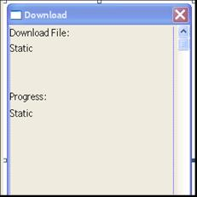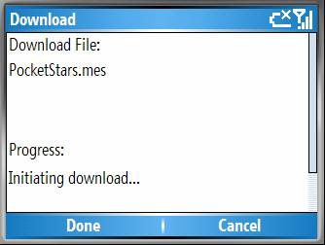

Used to download auxiliary data files.
Only the title and “Download File” and “Progress” need translation.

IDD_FIND
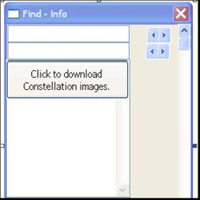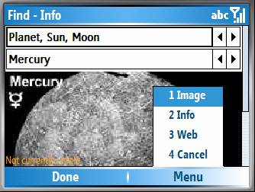
Used to search for objects and center them on the screen.
Only the title and single pushbutton need translation.

IDD_LANGUAGE
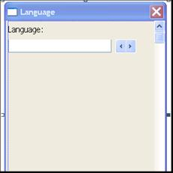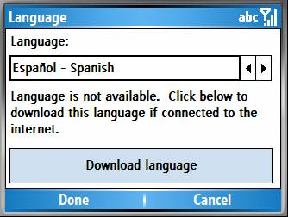
Used to select a UI language. Most of the contents are taken from the String table.

IDD_LOCATION
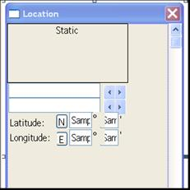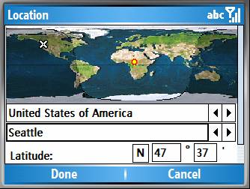
Used to set the user’s current location.
Only the title and Latitude and Longitude need translation.

IDD_LUNAR
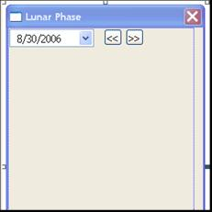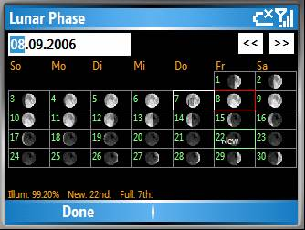
Shows the lunar phase.
Only the title needs translation.

IDD_PREFERENCES
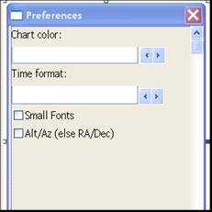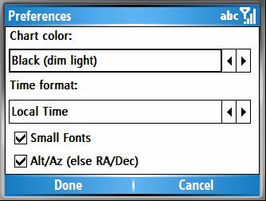
Selects star chart display preferences.

IDD_REGISTRATION
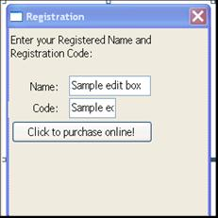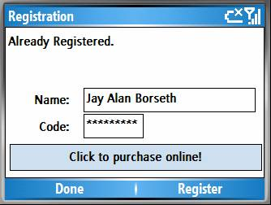
Used to register Pocket Stars.

IDD_RISESET
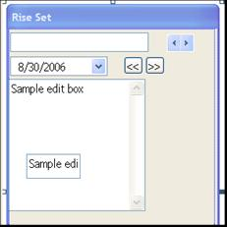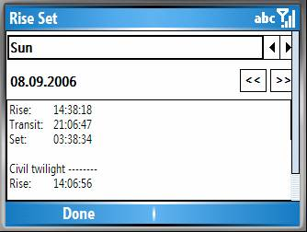
Rise, Transit, and set times for the selected body.
Only the title needs translation.

IDD_SPLASH
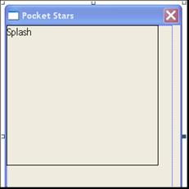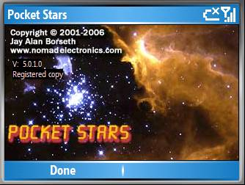
Splash and About screen.
Nothing to be translated.

IDD_TIME
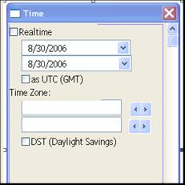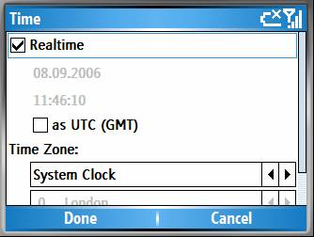
Sets the time for which the star chart is generated.

IDD_VIEW
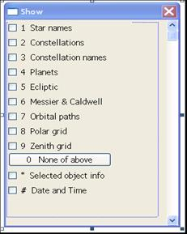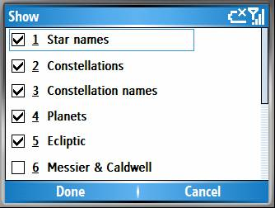
Selects which objects to view.

Menus
This is the main Pocket Stars SP menu. All menu resources are contained within PocketStars.rc. There are also a few other two or three line menus to be translated.

